Galactic Shooter
1.Introduction - what did you set out to do (objectives)
I have planned to create a base on a space shooter game called “Galactic Shooter” The main objective of the game is for players to navigate through levels, destroy all enemy ships, avoid obstacles, and achieve the highest score.
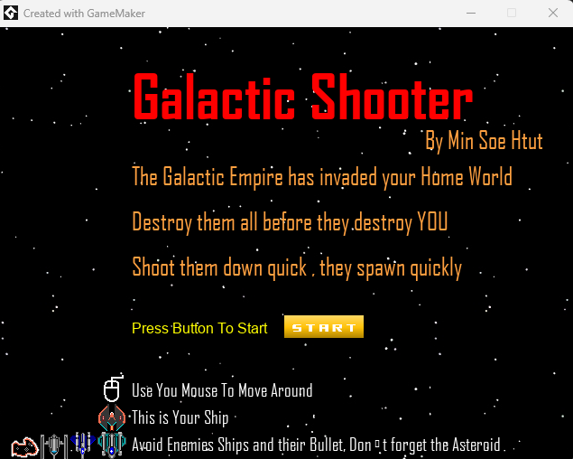
Figure 1: A screen of the intro screen
2.Design - how did you approach the problem (use your sketches to help explain)
The player ship will be firing three bullets and once I collect the weapon update it will shoot faster, enemy ships will move down from the top of the screen, and once it moves out of the screen it will jump back to the top. There will be multiple rooms for the player to enjoy, The Start Screen to introduce the player to what is the game about and basic guide on how to play the game.
2.1Conceptualization:
The design phase began with identifying key game objects and their functions. The player's ship, enemy ships, and asteroids were the primary elements considered.
2.3Player Interaction:
A pivotal design decision was enabling player movement via the mouse. This choice was intended to enhance user engagement and control precision.
2.3Enemy Mechanics:
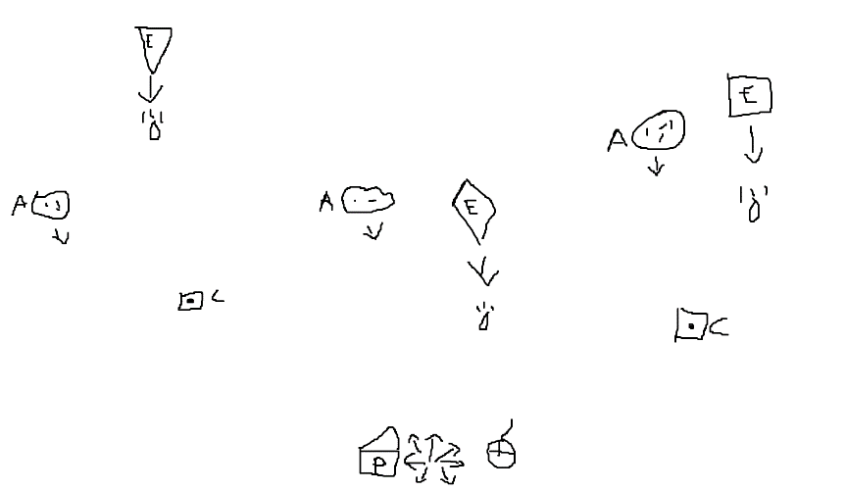
Enemy ships were designed to spawn randomly at the top of the screen, creating a dynamic challenge. To maintain gameplay continuity, enemies reappear at the top after leaving the screen.
Obstacles:
Asteroids were introduced as an additional obstacle that required players to employ strategy and quick reflexes.
Level Design:
A multiple-room structure rather than a single-room endless wave of enemies was conceptualized to progressively increase the game's difficulty and complexity.
Figure 2: A sketch of the game design on paper.
P = Player E = Enime C = Collectible A = Asteroid
3.Build - how did you put it together (remembering to explain why you did it that way) - use screenshots to illustrate your process.
The game itself is fast-paced so the player needs to have quick precision control. So I first implemented the mouse mechanic to the player ship for control precision to shoot and avoid the fast-moving and random-firing enemy ships. The Player also needs to avoid the Asteroids & collect the collectable. By having a multiple room, I can introduce a new enemy per room rather than the player can only climb the highest score in an unending wave of enemies.
3.1Development Stages:
Enemy Spawning: Implemented random spawning of enemy ships at the screen's top.
Asteroid Mechanics: Integrated moving asteroids that players must avoid.
Level Progression: Developed a level structure with multiple rooms.
Scoring System: Established a point system based on asteroid avoidance.
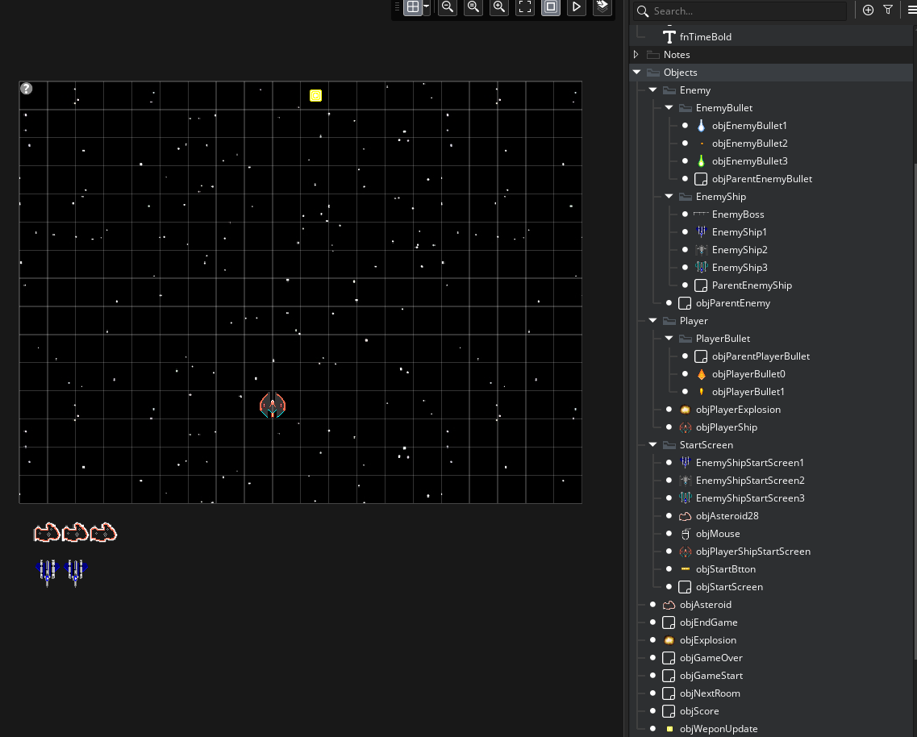
3.2Challenges Encountered:
Enemy spawning was problematic, with a lack of randomness and dependency on existing ships.
Difficulty in implementing random collectable spawns.
The enemy spawning mechanism lacked the desired sophistication.
Difficulty in mechanics of the guided missile.
When the End Condition of the room is met, it doesn’t jump to the next room completely.

Figure 3: A screenshot of the game development

4.1Player  The player ship uses the jump to point function to move around using the mouse by setting mouse_x, mouse_y. For the bullet Fire Rate, the count increases by +1 by every game step, once it reaches 60 it fires Three Bullet  then sets the count to 0 and repeats the step. Once the All Enemy are destroyed move to the next room. Below is the code for firing three bullets at the same time.  // Create Top Bullet  var topBullet = instance_create_layer(x, y, "Instances", objPlayerBullet0);  with (topBullet) {direction = 90;}  // Create Top-Left Bullet  var topLeftBullet = instance_create_layer(x, y, "Instances", objPlayerBullet1);  with (topLeftBullet) {direction = 135;}  // Create Top-Right Bullet  var topRightBullet = instance_create_layer(x, y, "Instances", objPlayerBullet1);  with (topRightBullet) {direction = 45;} | 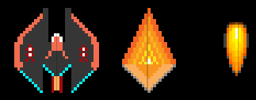  Figure 4.1.2 Screenshot of Player Ship & Bullets  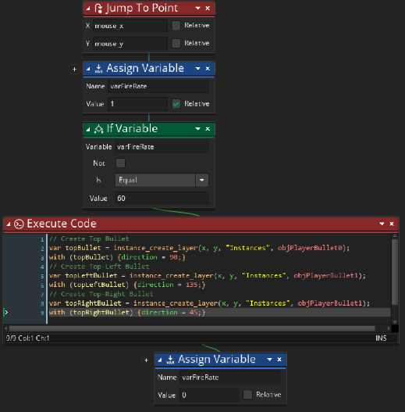  Figure 4.1.2 Screenshot of step even in obj player  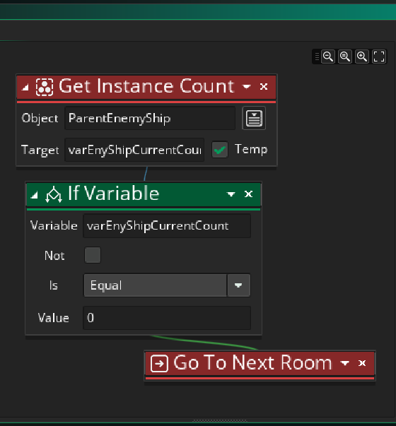  Figure 4.1.3 Screenshot of End step even in obj player
4.1Player  Once the Player hits with enemy ship, enemy bullet or asteroid the instance changes to objPlayerExplosion. In the objPlayerExplosion event ask the player to Enter Their Name to show it on the scoreboard. Then destroy the objPlayerExplosion and move to another room. Below is the code asking Name of the player.  //Create a variable to store the name of the player  var name = "";  //Ask the player to enter their name and store it  name = get_string("Please enter your name: ", "No Name");  //scoring system  highscore_add(name,global.playerScore); | 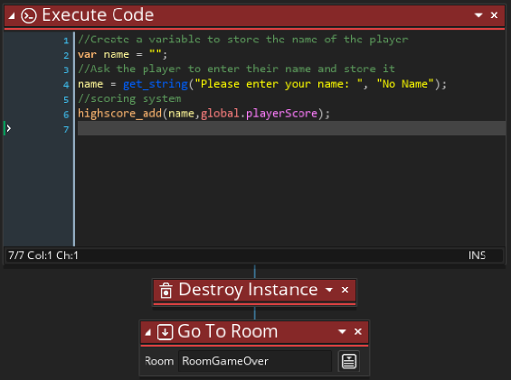  Figure 4.1.4 Screenshot of even in objPlayerExplosion
4. Result - what did you wind up with (and again use screenshots to show what you got)

4.2 Enemy  Enemy ships will spawn randomly at the top of the screen and move down to the bottom. If the same type of ship is less than 5 it will create a new enemy at the top. The enemy will reappear at the top after leaving the screen. They will fire randomly in a straight direction.  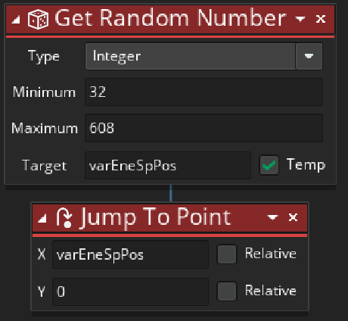  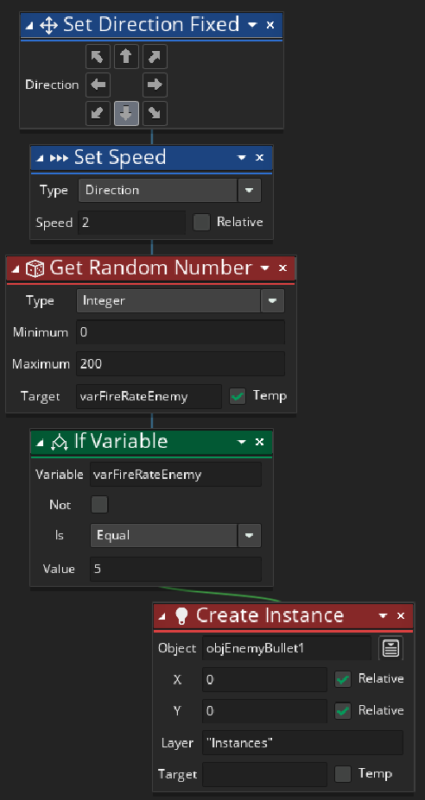  Figure 4.2.4 Screenshot of Outside Room  the event in Enemy Ship  Figure 4.2.3 Screenshot of Begin Step Event in Enemy Ship | 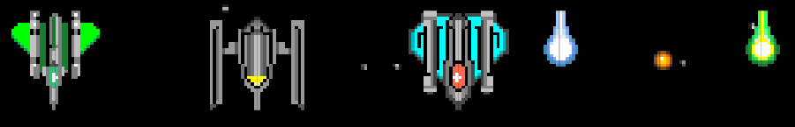  Figure 4.2.1 Screenshot of Enemy Ships & Bullets  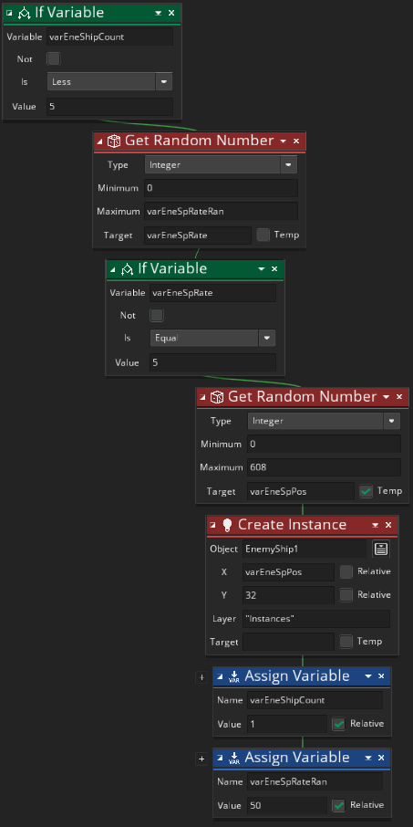  Figure 4.2.2 Screenshot of Step Event in Enemy Ship
4.2 Enemy  When the enemy ship is destroyed by the player, add the Score count by 5 and spawn the collectable randomly at the area where the ship has been destroyed.  Destroy the player bullet and change the instance to the ObjExplostion. | 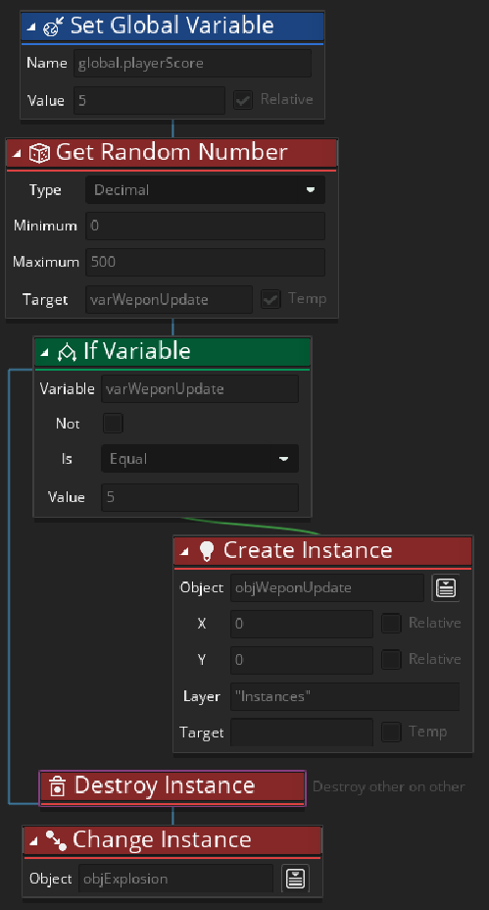  Figure 4.2.5 Screenshot of Collection vent with  Player Bullet in Enemy Ship

4.3 Asteroid  Asteroids are an additional obstacle that players need to avoid. Once it exits from the screen player gets 5 Points for a Score and it will reappear at a random location at the top of the screen. |   Figure 4.3.1 Screenshot of Asteroid

4.4 Collectable  Collectable will move down from the top for a player to collect. Once it exits from the screen it will reappear at a random location at the top of the screen. When the player collects the collectable they will provide the player with 10 points for Score. |  |   Figure 4.4.1 Screenshot of Collectable
 | 4.5 Scoring System & High Score Table  The scoring system is where the player can keep track of the score for destroying enemy ships, collecting collectables, and avoiding asteroids. At the end of the Game when a player dies or wins the game player will be asked to Fill in their Name and their height score will be displayed at the table for this run. | 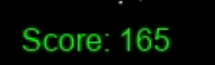  Figure 4.5.1 Screenshot of Live Score  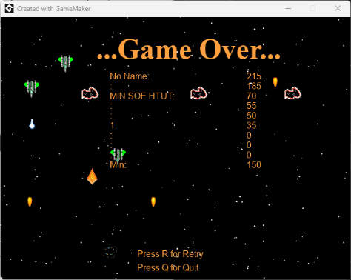  Figure 4.5.1 Screenshot of High Score Table
4.6 Room And Sound  There is a Start Screen where players are introduced to what is the game about and a basic guide on how to play the game.  There is a Test Room that the developer can use to try out the object.  There are 4 total playable rooms where the player can face the enemy.  After each room, there were where players could decide to go to the next room or quit a room.  There is a Room for when players win the game or lose the game where the player can see their high score.  There is a Sound for each room and a sound for collectables.  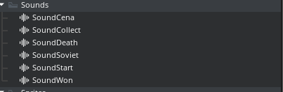  Figure 4.6.4 Screenshot of Sounds | 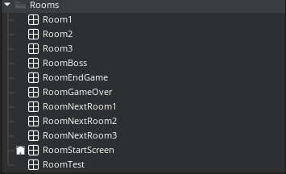  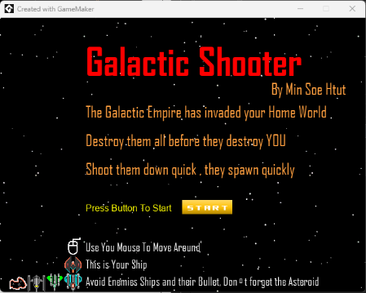  Figure 4.6.1 Screenshot Rooms  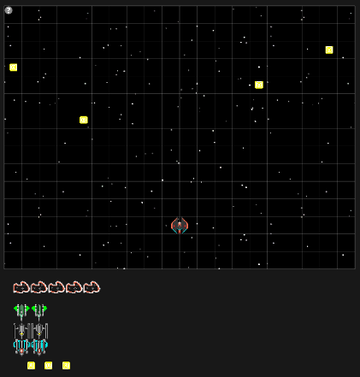  Figure 4.6.2 Screenshot of Start Screen  Figure 4.6.3 Screenshot of playable Room

5. Reflection - is that what you meant to do, how did it go, are you happy with that
5.1 Time Investment:
Approximately 42-45 hours were dedicated, primarily focusing on creating the game, debugging, and refining mechanics.
5.2 Achievements and Shortcomings:
While the primary objectives were mostly met, additional features and bug fixes remain. The Remaining functions that need debugging and rework mechanics are guided missile, collectable, Final Boss, and Room jumping.
5.3 Learning Experience:
Understanding of game mechanics and how they interact to create a cohesive and engaging player experience. The process of designing and implementing features like enemy behaviors, obstacle dynamics, and player controls was critical in understanding the delicate balance required in game design. A substantial portion of the development process was dedicated to troubleshooting and resolving unexpected issues. This involved debugging code, refining game mechanics, and ensuring smooth gameplay. The challenges encountered necessitated a methodical approach to problem-solving and creative and innovative solutions. Creating a game required adaptability and a willingness to learn new techniques and technologies. The development process highlighted the importance of patience and persistence. Creating a game, especially one that is engaging and bug-free, is a time-consuming process that often involves revisiting and revising many aspects of the game multiple times. The skills and knowledge gained through this process are invaluable and will undoubtedly be beneficial in future projects.
6. Cost/time analysis - did it go to plan/was it cost-effective
Development Efficiency:
The time invested versus the project's current stage reflects moderate development efficiency. The learning curve and debugging phases were particularly time-consuming.
6.1 Expectation Alignment:
The time commitment broadly aligns with initial expectations, though some aspects require more time than anticipated.
6.2 Conclusion - did you meet your objectives (a summary of the previous few sections)
"Galactic Shooter" has made commendable progress towards achieving its initial objectives. However, further development is necessary to resolve current issues and add new features. The project has been both challenging and rewarding, closely aligning with the envisioned game concept. Despite the need for further improvements, the journey of developing "Galactic Shooter" has been a combination of a series of challenges and achievements.

